Assignment no. 7

1)Write a query that counts all orders for October 3.
Ans :-
select count(*) from ORDERS where odate = '1990-10-03';

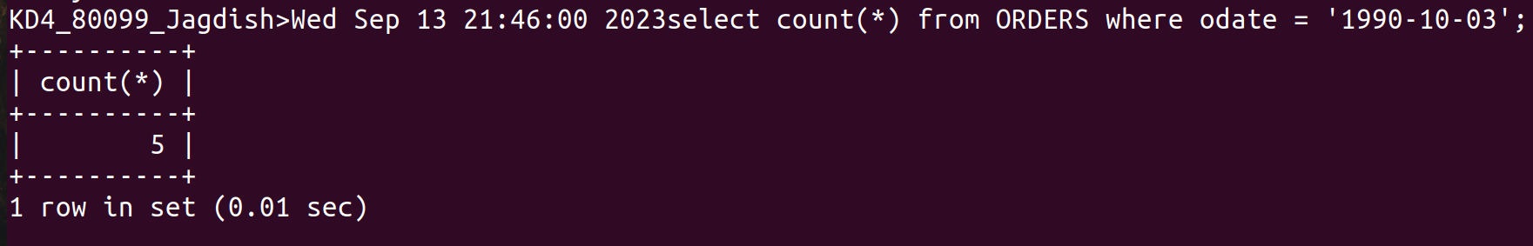

2) Write a query that counts the number of different non-NULL city values in the customer table.
Ans :-

select count(*) from CUSTOMERS where city is not null;

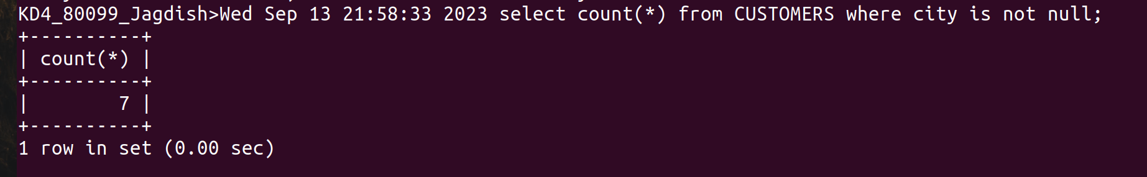
3) Write a Query that selects each customer’s smallest order.
Ans:-

select cnum,min(amt) from ORDERS group by cnum;
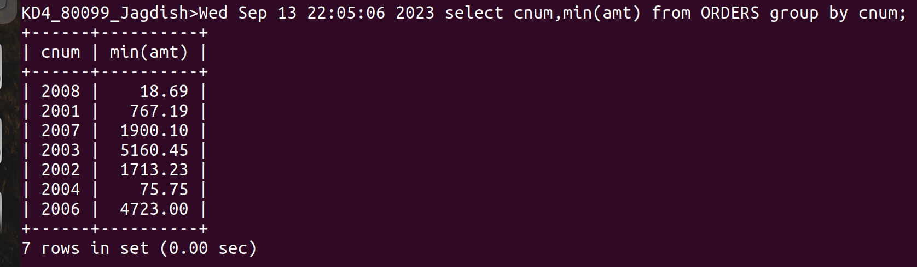
4) Write a query that selects the first customers in alphabetical order, whose name begins with G.

Ans:-
select min(cname) from CUSTOMERS where cname like 'G%';

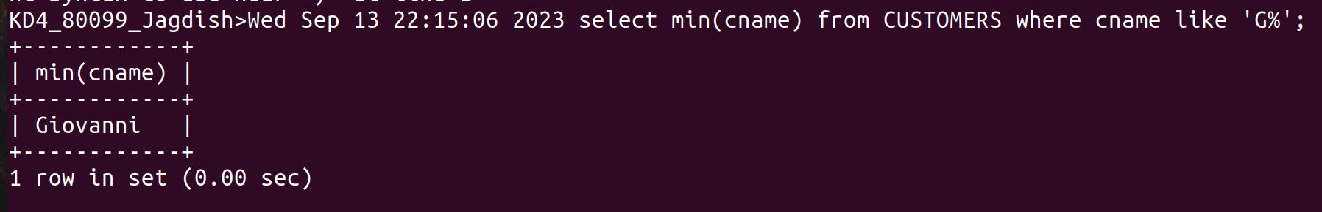
5) write a query that selects the highest rating in each city.

Ans:-

select city,max(rating) from CUSTOMERS group by city;

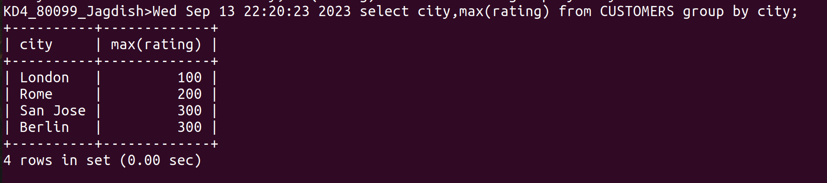
6) Write a query that counts the number of salespeople registering orders for each day.(if a salesperson has more than one order on a givenday, he or she should be counted only once.)

Ans:-
select count(distinct snum) from ORDERS group by odate;
